**Report “Lab 7”**

**Anton Tserakhau**

# Create and populate Dimension of TIME DW – Layer

I have created tablespace and user, granted roles to user:

CREATE TABLESPACE ts_dw

DATAFILE 'db_qpt_dw_01.dat'

SIZE 200M

AUTOEXTEND ON NEXT 100M

SEGMENT SPACE MANAGEMENT AUTO;

CREATE USER u_dw

IDENTIFIED BY "%PWD%"

DEFAULT TABLESPACE ts_dw

QUOTA UNLIMITED ON ts_dw;

GRANT RESOURCE, CONNECT TO u_dw;

Time period: 01.01.2012-31.12.2012

## Task 01: CREATE DW.T_DAYS

I have created table T_DAYS:

CREATE TABLE T_DAYS AS

SELECT

TRUNC( sd + rn ) time_id,

TO_CHAR( sd + rn, 'fmDay' ) day_name,

TO_CHAR( sd + rn, 'D' ) day_number_in_week,

TO_CHAR( sd + rn, 'DD' ) day_number_in_month,

TO_CHAR( sd + rn, 'DDD' ) day_number_in_year

FROM

(

SELECT

TO_DATE( '12/31/2011', 'MM/DD/YYYY' ) sd,

rownum rn

FROM dual

CONNECT BY level <= 366

);

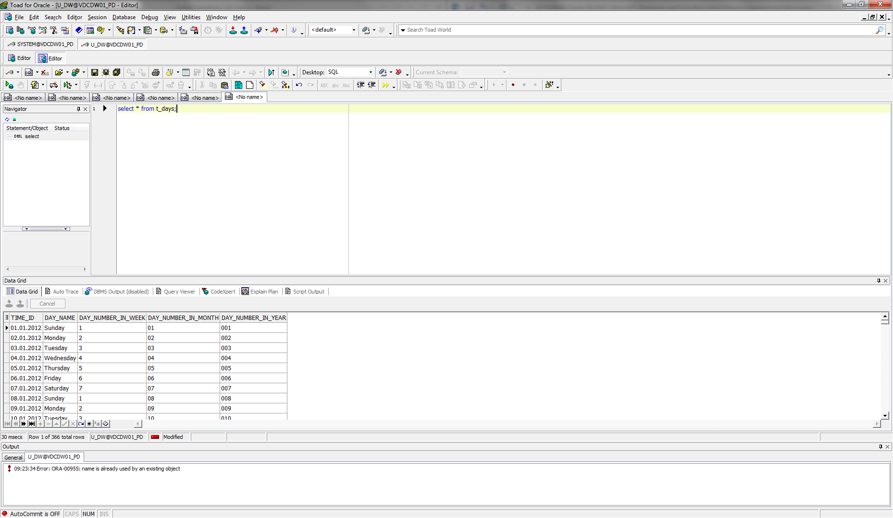

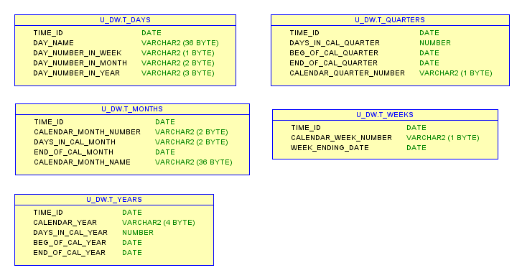

## Task 02: CREATE DW.T_WEEKS

I have created table T_WEEKS:

CREATE TABLE T_WEEKS AS

SELECT

TRUNC( sd + rn ) time_id,

TO_CHAR( sd + rn, 'W' ) calendar_week_number,

( CASE

WHEN TO_CHAR( sd + rn, 'D' ) IN ( 1, 2, 3, 4, 5, 6 ) THEN

NEXT_DAY( sd + rn, 'Saturday' )

ELSE

( sd + rn )

END ) week_ending_date

FROM

(

SELECT

TO_DATE( '12/31/2011', 'MM/DD/YYYY' ) sd,

rownum rn

FROM dual

CONNECT BY level <= 366

);

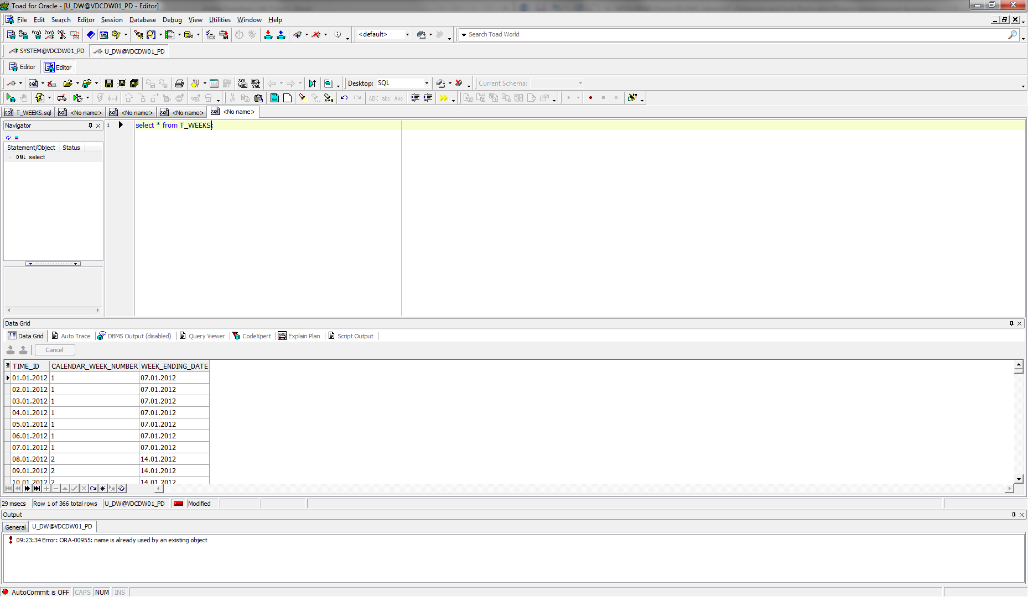



## Task 03: CREATE DW.T_MONTHS

I have created table T_MONTHS:

CREATE TABLE T_MONTHS AS

SELECT

TRUNC( sd + rn ) time_id,

TO_CHAR( sd + rn, 'MM' ) calendar_month_number,

TO_CHAR( LAST_DAY( sd + rn ), 'DD' ) days_in_cal_month,

LAST_DAY( sd + rn ) end_of_cal_month,

TO_CHAR( sd + rn, 'FMMonth' ) calendar_month_name

FROM

(

SELECT

TO_DATE( '12/31/2011', 'MM/DD/YYYY' ) sd,

rownum rn

FROM dual

CONNECT BY level <= 366

);

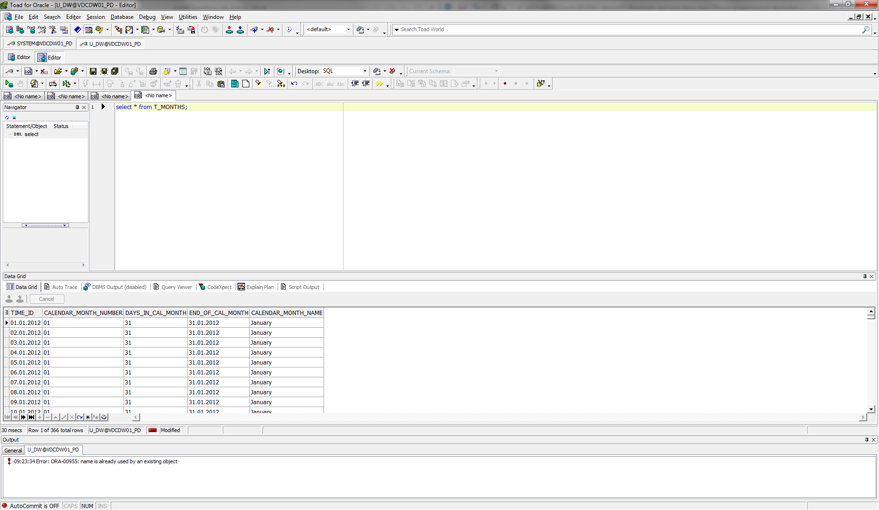



## Task 04: CREATE DW.T_QUARTERS

I have created table T_QUARTERS:

CREATE TABLE T_QUARTERS AS

SELECT

TRUNC( sd + rn ) time_id,

( ( CASE

WHEN TO_CHAR( sd + rn, 'Q' ) = 1 THEN

TO_DATE( '03/31/' || TO_CHAR( sd + rn, 'YYYY' ), 'MM/DD/YYYY' )

WHEN TO_CHAR( sd + rn, 'Q' ) = 2 THEN

TO_DATE( '06/30/' || TO_CHAR( sd + rn, 'YYYY' ), 'MM/DD/YYYY' )

WHEN TO_CHAR( sd + rn, 'Q' ) = 3 THEN

TO_DATE( '09/30/' || TO_CHAR( sd + rn, 'YYYY' ), 'MM/DD/YYYY' )

WHEN TO_CHAR( sd + rn, 'Q' ) = 4 THEN

TO_DATE( '12/31/' || TO_CHAR( sd + rn, 'YYYY' ), 'MM/DD/YYYY' )

END ) - TRUNC( sd + rn, 'Q' ) + 1 ) days_in_cal_quarter,

TRUNC( sd + rn, 'Q' ) beg_of_cal_quarter,

( CASE

WHEN TO_CHAR( sd + rn, 'Q' ) = 1 THEN

TO_DATE( '03/31/' || TO_CHAR( sd + rn, 'YYYY' ), 'MM/DD/YYYY' )

WHEN TO_CHAR( sd + rn, 'Q' ) = 2 THEN

TO_DATE( '06/30/' || TO_CHAR( sd + rn, 'YYYY' ), 'MM/DD/YYYY' )

WHEN TO_CHAR( sd + rn, 'Q' ) = 3 THEN

TO_DATE( '09/30/' || TO_CHAR( sd + rn, 'YYYY' ), 'MM/DD/YYYY' )

WHEN TO_CHAR( sd + rn, 'Q' ) = 4 THEN

TO_DATE( '12/31/' || TO_CHAR( sd + rn, 'YYYY' ), 'MM/DD/YYYY' )

END ) end_of_cal_quarter,

TO_CHAR( sd + rn, 'Q' ) calendar_quarter_number

FROM

(

SELECT

TO_DATE( '12/31/2011', 'MM/DD/YYYY' ) sd,

rownum rn

FROM dual

CONNECT BY level <= 366

);

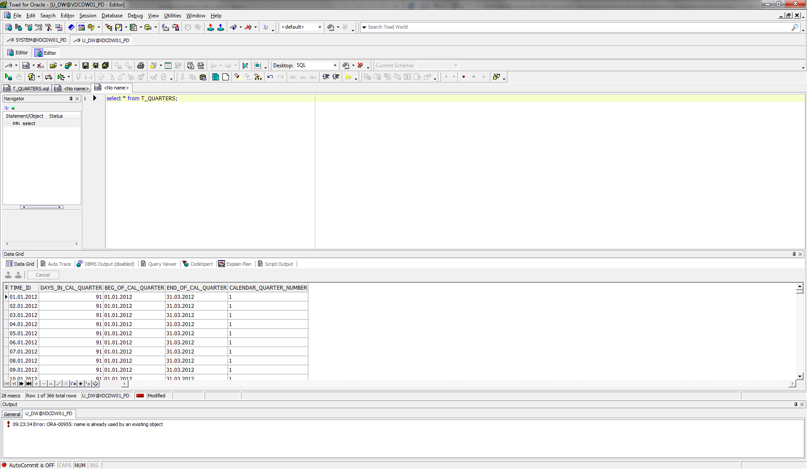



## Task 05: CREATE DW.T_YEARS

I have created table T_YEARS:

CREATE TABLE T_YEARS AS

SELECT

TRUNC( sd + rn ) time_id,

TO_CHAR( sd + rn, 'YYYY' ) calendar_year,

( TO_DATE( '12/31/' || TO_CHAR( sd + rn, 'YYYY' ), 'MM/DD/YYYY' )

- TRUNC( sd + rn, 'YEAR' ) ) days_in_cal_year,

TRUNC( sd + rn, 'YEAR' ) beg_of_cal_year,

TO_DATE( '12/31/' || TO_CHAR( sd + rn, 'YYYY' ), 'MM/DD/YYYY' ) end_of_cal_year

FROM

(

SELECT

TO_DATE( '12/31/2011', 'MM/DD/YYYY' ) sd,

rownum rn

FROM dual

CONNECT BY level <= 366

);

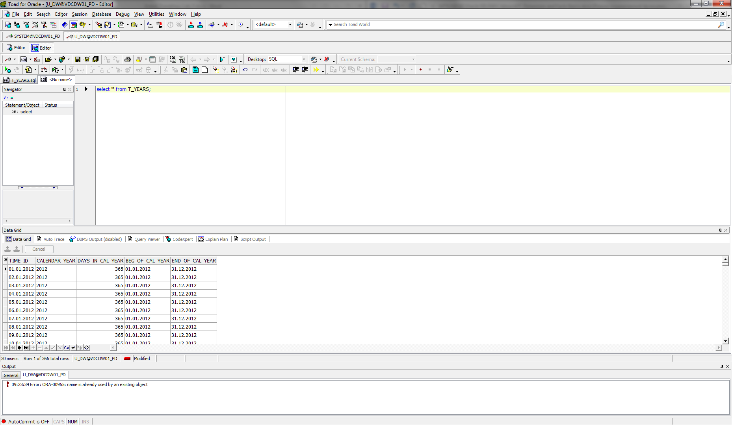



The diagram with all tables:

